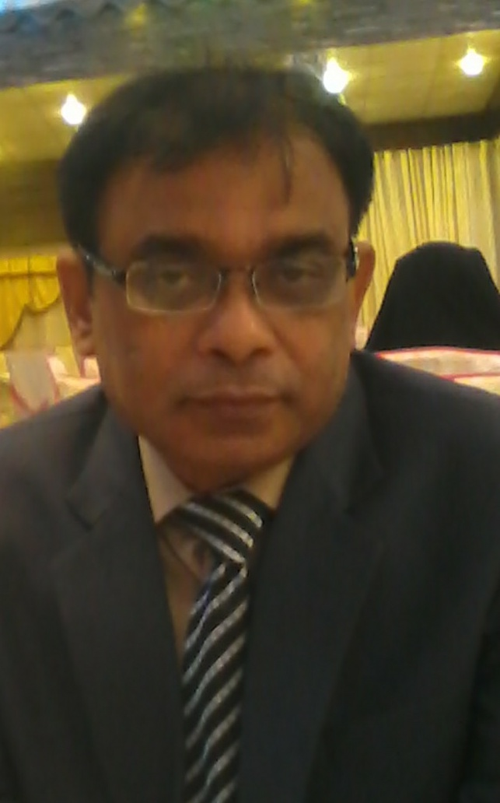**Curriculum Vitae**

**PERSONAL DATA:**

Name: Shoaib Alam. Nationality: Pakistani

Date of Birth: 1st Dec. 1964. Passport # B1636828

Marital Status: Married. N.I.C No.: 421016-218558-1.

Address: B- 121- Block L, N. Nazimabad Phone (Res.): 92-21-36648526.

Karachi, 74700 Pakistan. Email Address: shoaibalam36@hotmail.com.

Cell #: 0092-3002010632

**ACADEMIC PROFILE:**

* Bachelor in Civil Engineering from **N.E.D University of Engineering and Technology**, Karachi, in 1st Division (80%).
* Intermediate (Pre-Engineering) from Board of Intermediate and Secondary Education Karachi, in 1st Division.

**PROFESSIONAL MEMBERSHIP:**

 Member of Pakistan Engineering Council, Registration No. 12925.

**SPECIAL TRAININGS:**

* Under **ALCATEL ITALIA** (Egypt Branch) attended Management Training Course on following topics organized by **(MCC)** Management Consult Center: **Cairo.**

* EFECTIVE TEAM BUILDING.

* CREATIVE PROBLEM SOLVING. * USING TIME EFFECTIVELY.

* MANAGEMENT RE-ENGINEERING.

* Under the training program of ALCATEL (French – Multinational Tele. Com) received training of OSP Telecommunication Network, which includes, Designing of Telecom Network, Cable Laying, Splicing, Testing and Termination of Copper and Fiber Optic Cable.

**PROFESSIONAL EXPERIENCE:**

**May 2009 till Todate:**.Self employed on construction supervision of project for Ministry of industries and providing consultancy services for **Warid & Telenor (GSM network service Providers}**  for south region in Pakistan.

**SEP’04 till Jan April 2009:** Worked with **Siemens** / **NSN(Nokia Siemens Networks)** on GSM network installation forTelenor Projecton various positions of  **Regional Manager/Project Engineer Site Acquisition, Area rollout Manager** Phase2 Karachi and **civil Engineer.**.as per project requirement.

**MAJOR RESPONSIBILITIES:**

.As RM/PE Site acquisition, responsible for work progress to meet SA targets for south region supervising Siemens /NSN team & subcontractors.

As Area Rollout Manager, Successfully completed the task of final site preparation and acceptance of all phase 2 sites in Karachi and Hub (Bluchistan) till their provisional acceptance by Telenor.

As Civil Engineer, conducted inspection and primary acceptance of various roof top and green field sites by preparing technical site survey (TSS) reports for Karachi & Hyderabad region along with RF and MW engineers.

*Inspection of GSM Network installation carried out by the subcontractor to maintain Quality control of various roof top and green field sites in Karachi, which involves civil work, installation of green field and roof top tower, shelter and feeder cable, grounding system, air-conditioning, temporary and permanent power supply system...

*Co-ordination b/w client and subcontractor to resolve difficulties during execution of work to achieve smooth progress.

*Primary approval of work done by the subcontractor and co-ordination with client for final acceptance.

**APR’03 To JUL’03:** Worked with **Alcatel Italia** (**Nigeria branch**) as **Site coordinator / Quality control Engineer** on Backbone project of **Globacom** for fiber optic link between Lagos and Abuja.

**SEP’98 To MAR’02:** Worked with **ALCATEL ITALIA** (Egypt Br. ISO 9002 Certified) on **Nile Vision Project** forTelecom Egypt.

In charge of **OSP Telecom Net Work Installation** of 2 sectors in Sharkeya Governorate consisting of 20 exchanges.

 Major responsibilities:

To plan and organize work schedule to meet the target set by Company through coordination with client and subcontractor.

To inspect and control the work progress directly and through ALCATEL Team of field Engineers & supervisors.

To implement the ISO quality procedures in order to avoid or remove any non-conformity.

Primary approval of work done by the subcontractor and co-ordination with client for acceptance. Implementation of management policies & preparation of weekly and monthly reports **OCT’96 To FEB’97:** Worked with **ALCATEL** Contracting **(Indonesia Branch)** under KSO PRIMINDO IKAYTNUSANTARA Project in Sumatra for Indonesian Telecom as Site Manager.

 Major responsibilities:

Inspection of O.S.P. Network installation carried out by the subcontractor to maintain Quality control.

Co-ordination b/w the representative of client and ALCATEL to resolve difficulties during execution of work to achieve smooth progress.

Primary approval of work done by the subcontractor and co-ordination with client for final acceptance. Implementation of management policies at site & preparation of weekly and monthly reports.

**JUL’94 To OCT’96:** Worked with **PROMET Engineering** (**Singapore Based Multinational**) as a **Quality Control Engineer** during the construction of Fauji Oil Terminal Project at port Qasim, Karachi.

Supervised the installation of edible oil pipe line on 4 km off Shore Bridge to the pumping station.

Responsible for the inspection of pre cast and pre stressed double T-beam during casting and placement on 4 km trussle in the deep sea performed by the sub contractor.

Field inspection and approval of checklist for the work preparation of on-shore causeway and double T beams. Preparation of weekly and monthly progress reports to update Singapore Head office.

As a local representative of PROMET, involved in the following projects of company’s interest:

* **LIQUID CARGO TERMINAL AT PORT QASIM:**

Assisted Singapore office in cost evaluation, by providing the required technical and legal information through Port Qasim and other authorities for the submission of tender.

* **KARACHI NORTHERN BYPASS:**

As a client representative, followed the soil investigation and testing performed by M/s Consolidated Engineering Services, for the nine Km route, passing through marshy land of KPT and Naval area.

Conducted and attended various high level meetings with different government agencies concerned with the project including National Highway Authority (NHA). Pakistan Navy, Karachi Port Trust (KPT), Karachi Development Authority (KDA), Liyari Development Authority (LDA), Commissioner Karachi and IG Traffic Karachi, in order to get necessary approval.

Organized and followed the field survey (together with NHA, PN, LDA and other govt. agencies) conducted by 3rd party (Geodetic International inc. and Meinhardt) as per standard requirement of Promet.

Developed and submitted a preliminary field report of 63 Km route alignment, covering the physical outlook of strata, type of soil and flora & forna at every 500 meters, supported by the photographs.

Prepared a detailed survey report of major raw materials and equipment suppliers based on comparative rate analysis, available in the local market.

* **GAWADER DEEP WATER PORT:**

As a Promet representative, coordinated with KPT and provided necessary information as desired by the Singapore office for cost evaluation of the project.

* **REAL STATE BUSINESS:**

Prepared a preliminary survey report of various locations in Karachi and Islamabad (owned by KPT, PN and other agencies) as desired by Singapore office for investment in different construction projects.

**JUN’92 To DEC’93:** Served ALCATEL Contracting (**French – Multinational Tele.Com**) on its B.L.T. Project for **Pakistan Telecom Corporation** consisting of more than 300,000 lines, 182,000 subscribers’ connection andinstallation of F.O. Cable with following major responsibilities:

As O.S.P. Tele.Com Engineer, supervised the work as cable laying and splicing in charge of different sections of Karachi and Quetta (Balochistan Province).

Trained more than 20 batches of ALCATEL local staff and subcontractor’s technicians in different sections of O.S.P. network as per site requirement.

As training instructor, trained three batches of P.T.C. and one batch of instructors of P.T.C., which covers civil work, cable laying, splicing and termination of copper and Fiber Optic Cable.

As the member of selection team of ALCATEL conducted the aptitude test and interviews to select the trainees of client (P.T.C) for their local and final training in France.

Performed splicing, testing and termination of Fiber Optic Cable using Fujicora splicing Machine and O.T.D.R.

**DEC’90 To JUN’92:** Worked with **SOGEA Pakistan Branch** (**French Multi National Construction Company**) as **Quality control engineer** during construction of **Quaid-e-Azam International Airport Project**, at Karachi.

Followed the work supervision and inspection of plumbing and sewage system of East & West satellite buildings. Followed the various other activities of SOGEA Finishing department, started as junior Engineer and released after

Project completion as **Civil Quality Control Engineer**

**COMPUTER SKILLS:** Can operate packages like Ms Excel and Ms Word.